Jeremy Scheuerman

Dr. Wang

Lab_6.2

6.5

Exercise 1

|  |  |  |  |  |  |
| --- | --- | --- | --- | --- | --- |
| **GLOBAL** | **Main** | **Main (inner 1)** | **Main (inner 2)** | **Area** | **Circumference** |
| const PI | Float radius | Float area | Float radius | Float rad | Float length |
| Const RATE |  |  | Float circumference | Float answer | Float distance |
| Void findArea |  |  |  |  |  |
| Void findCircumference |  |  |  |  |  |
|  |  |  |  |  |  |
|  |  |  |  |  |  |
|  |  |  |  |  |  |

Exercise 2

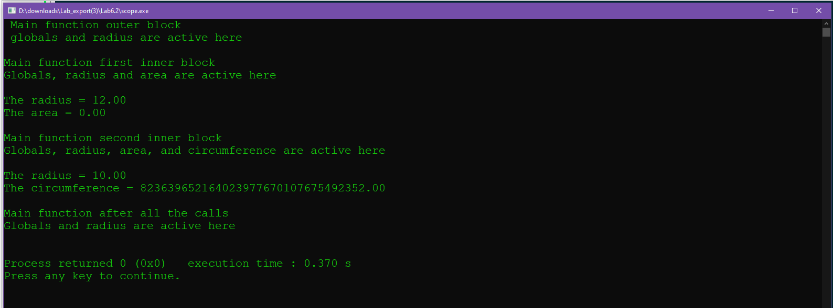

Exercise 3

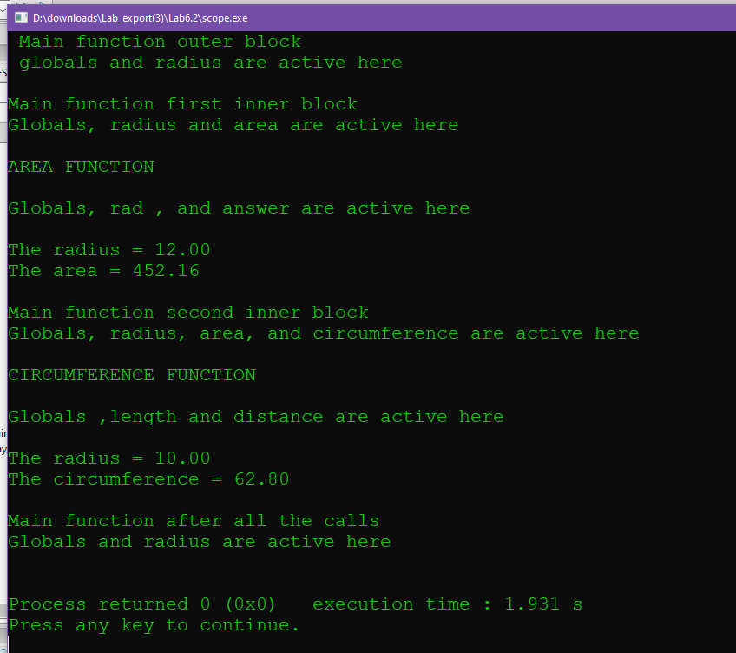

Exercise 4

Radius will be 10

Radius will be 12

This is because of variable scoping also radius is re defined in the second block

Exercise 5/source code

#include <iostream>

#include <iomanip>

using namespace std;

// This program will demonstrate the scope rules.

// PLACE YOUR NAME HERE

const double PI = 3.14;

const double RATE = 0.25;

void findArea(float, float&);

void findCircumference(float, float&);

int main()

{

cout << fixed << showpoint << setprecision(2);

float radius = 12;

cout << " Main function outer block" << endl;

cout << " globals and radius are active here" << endl << endl;

{

float area;

cout << "Main function first inner block" << endl;

cout << "Globals, radius and area are active here" << endl << endl;

// Fill in the code to call findArea here

findArea(radius,area);

cout << "The radius = " << radius << endl;

cout << "The area = " << area << endl << endl;

}

{

float radius = 10;

float circumference;

cout << "Main function second inner block" << endl;

cout << "Globals, radius, area, and circumference are active here" << endl << endl;

// Fill in the code to call findCircumference here

findCircumference(radius,circumference);

cout << "The radius = " << radius << endl;

cout << "The circumference = " << circumference << endl << endl;

}

cout << "Main function after all the calls" << endl;

cout << "Globals and radius are active here" << endl << endl;

return 0;

}

// *********************************************************************

// findArea

//

// task: This function finds the area of a circle given its radius

// data in: radius of a circle

// data out: answer (which alters the corresponding actual parameter)

//

// ********************************************************************

void findArea(float rad, float& answer)

{

cout << "AREA FUNCTION" << endl << endl;

cout << "Globals, rad , and answer are active here" << endl << endl;

// FILL in the code, given that parameter rad contains the radius, that

// will find the area to be stored in answer

answer=PI*(rad*rad);

}

// ******************************************************************************

// findCircumference

//

// task: This function finds the circumference of a circle given its radius

// data in: radius of a circle

// data out: distance (which alters the corresponding actual parameter)

//

// *****************************************************************************

void findCircumference(float length, float& distance)

{

cout << "CIRCUMFERENCE FUNCTION" << endl << endl;

cout << "Globals ,length and distance are active here" << endl << endl;

// FILL in the code, given that parameter length contains the radius,

// that will find the circumference to be stored in distance

distance=2*length*PI;

}

6.6

Exercise 1

$1.93

However right now it just prints 0 because things haven’t been defined

Exercise 2

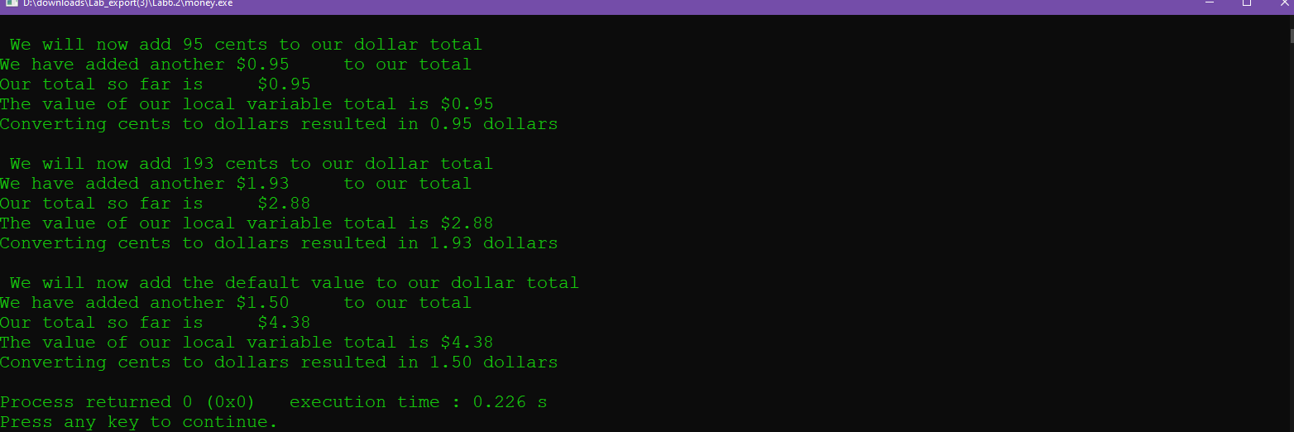

Source Code

#include <iostream>

#include <iomanip>

using namespace std;

// PLACE YOUR NAME HERE

void normalizeMoney(float& dollars, int cents = 150);

// This function takes cents as an integer and converts it to dollars

// and cents. The default value for cents is 150 which is converted

// to 1.50 and stored in dollars

int main()

{

int cents;

float dollars;

cout << setprecision(2) << fixed << showpoint;

cents = 95;

cout << "\n We will now add 95 cents to our dollar total\n";

// Fill in the code to call normalizeMoney to add 95 cents

normalizeMoney(dollars,cents);

cout << "Converting cents to dollars resulted in " << dollars << " dollars\n";

cout << "\n We will now add 193 cents to our dollar total\n";

// Fill in the code to call normalizeMoney to add 193 cents

cents=193;

normalizeMoney(dollars,cents);

cout << "Converting cents to dollars resulted in " << dollars << " dollars\n";

cout << "\n We will now add the default value to our dollar total\n";

// Fill in the code to call normalizeMoney to add the default value of cents

normalizeMoney(dollars);

cout << "Converting cents to dollars resulted in " << dollars << " dollars\n";

return 0;

}

//*******************************************************************************

// normalizeMoney

//

// task: This function is given a value in cents. It will convert cents

// to dollars and cents which is stored in a local variable called

// total which is sent back to the calling function through the

// parameter dollars. It will keep a running total of all the money

// processed in a local static variable called sum.

//

// data in: cents which is an integer

// data out: dollars (which alters the corresponding actual parameter)

//

//*********************************************************************************

void normalizeMoney(float& dollars, int cents)

{

static float total = 0;

// Fill in the definition of sum as a static local variable

static float sum = 0.0;

// Fill in the code to convert cents to dollars

dollars=cents*.01;

total = total + dollars;

sum += dollars;

cout << "We have added another $" << dollars << " to our total" << endl;

cout << "Our total so far is $" << sum << endl;

cout << "The value of our local variable total is $" << total << endl;

}

6.7

Exercise 1

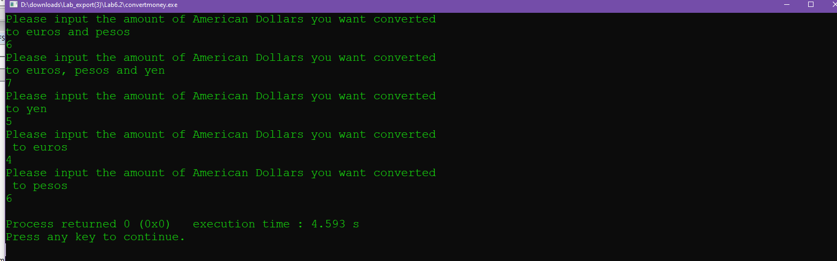

I assume scope and variable passing was not done correctly

Exercise 2

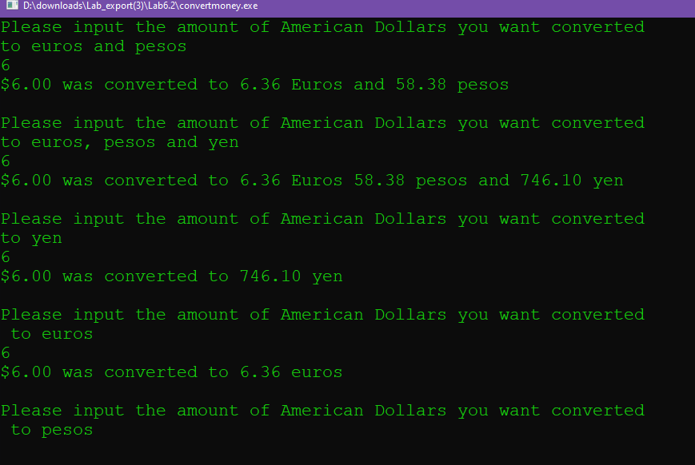

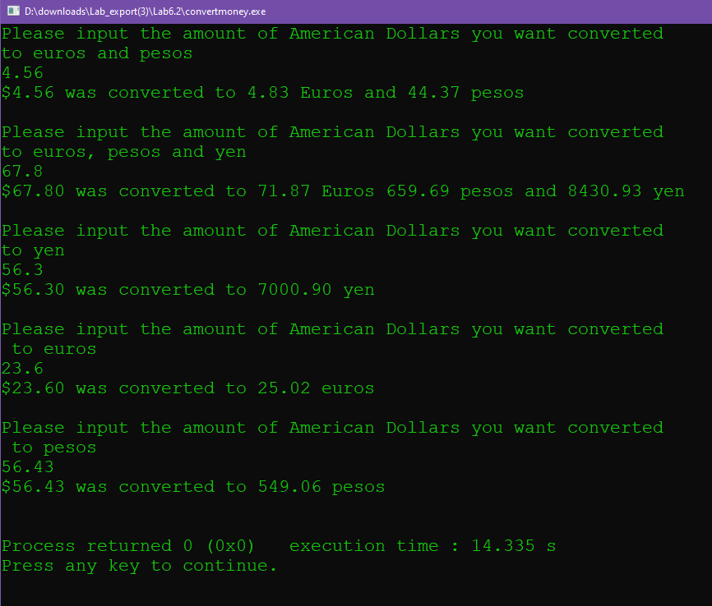

Source code

#include <iostream>

#include <iomanip>

using namespace std;

// This program will input American money and convert it to foreign currency

// PLACE YOUR NAME HERE

// Prototypes of the functions

void convertMulti(float dollars, float& euros, float& pesos);

void convertMulti(float dollars, float& euros, float& pesos, float& yen);

float convertToYen(float dollars);

float convertToEuros(float dollars);

float convertToPesos(float dollars);

const float TOEUROS=1.06;

const float TOPESOS=9.73;

const float TOYEN=124.35;

int main()

{

float dollars;

float euros;

float pesos;

float yen;

cout << fixed << showpoint << setprecision(2);

cout << "Please input the amount of American Dollars you want converted "

<< endl;

cout << "to euros and pesos" << endl;

cin >> dollars;

// Fill in the code to call convertMulti with parameters dollars, euros, and pesos

convertMulti(dollars,euros,pesos);

// Fill in the code to output the value of those dollars converted to both euros

// and pesos

cout << "Please input the amount of American Dollars you want converted\n";

cout << "to euros, pesos and yen" << endl;

cin >> dollars;

// Fill in the code to call convertMulti with parameters dollars, euros, pesos and yen

convertMulti(dollars,euros,pesos,yen);

// Fill in the code to output the value of those dollars converted to euros,

// pesos and yen

cout << "Please input the amount of American Dollars you want converted\n";

cout << "to yen" << endl;

cin >> dollars;

// Fill in the code to call convertToYen

convertToYen(dollars);

// Fill in the code to output the value of those dollars converted to yen

cout << "Please input the amount of American Dollars you want converted\n";

cout << " to euros" << endl;

cin >> dollars;

// Fill in the code to call convert ToEuros

convertToEuros(dollars);

// Fill in the code to output the value of those dollars converted to euros

cout << "Please input the amount of American Dollars you want converted\n";

cout << " to pesos " << endl;

cin >> dollars;

// Fill in the code to call convertToPesos

convertToPesos(dollars);

// Fill in the code to output the value of those dollars converted to pesos

return 0;

}

// All of the functions are stubs that just serve to test the functions

// Replace with code that will cause the functions to execute properly

// **************************************************************************

// convertMulti

//

// task: This function takes a dollar value and converts it to euros

// and pesos

// data in: dollars

// data out: euros and pesos

//

// *************************************************************************

void convertMulti(float dollars, float& euros, float& pesos)

{

pesos=dollars*TOPESOS;

euros=dollars*TOEUROS;

cout<< "$"<< dollars

<< " was converted to " <<euros<<" Euros and "<<pesos<<" pesos "<< endl << endl;

}

// ************************************************************************

// convertMulti

//

// task: This function takes a dollar value and converts it to euros

// pesos and yen

// data in: dollars

// data out: euros pesos yen

//

// ***********************************************************************

void convertMulti

6.8

Option 1

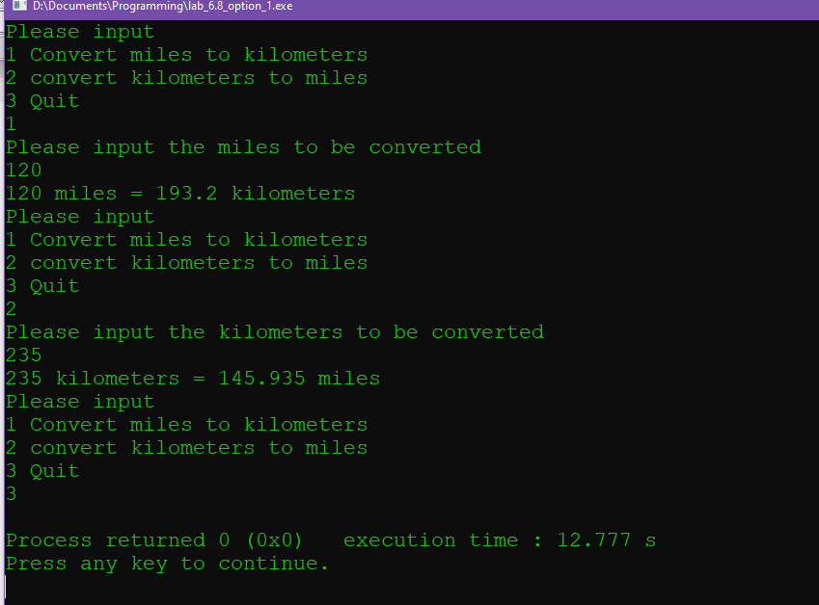

Source Code

#include <iostream>

using namespace std;

const float TOKM=.621;

const float TOMI=1.61;

float kmtomi();

float mitokm();

float kmtomi(float kilo)

{

float miles=0;

miles=kilo*TOKM;

return miles;

}

float mitokm(float miles)

{

float kilo=0;

kilo=miles*TOMI;

return kilo;

}

int main ()

{

int choice=4;

float miles=0;

float kilo=0;

while (choice!=3)

{

cout<<"Please input"<<endl<<"1 Convert miles to kilometers"<<endl<<"2 convert kilometers to miles"<<endl<<"3 Quit"<<endl;

cin>>choice;

if(choice==1)

{

cout<<"Please input the miles to be converted"<<endl;

cin>>miles;

kilo=mitokm(miles);

cout<<miles<<" miles = "<<kilo<<" kilometers"<<endl;

}

else if(choice==2)

{

cout<<"Please input the kilometers to be converted"<<endl;

cin>>kilo;

miles=kmtomi(kilo);

cout<<kilo<<" kilometers = "<<miles<<" miles"<<endl;

}

else if (choice==3)

{

break;

}

}

return 0;

}

Option 2

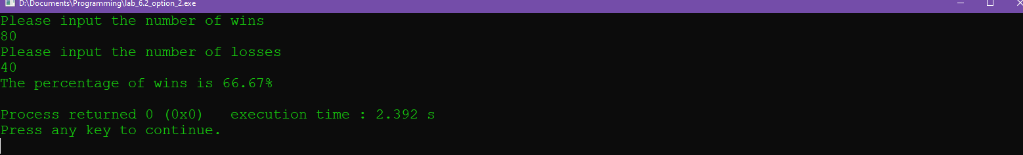

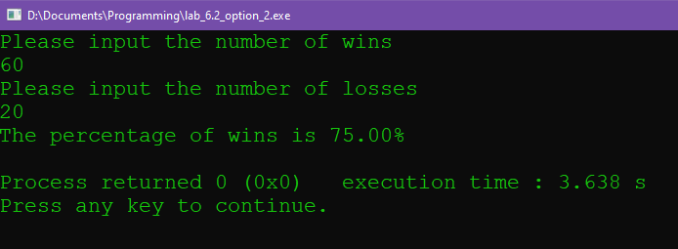

Soure Code

#include <iostream>

#include <iomanip>

using namespace std;

int num_wins();

int num_losses();

float percentage(int wins,int losses);

int num_wins()

{

//get wins

int amnt=0;

cin>>amnt;

return amnt;

}

int num_losses()

{

//get losses

int amnt=0;

cin>>amnt;

return amnt;

}

float percentage(int wins,int losses)

{

//do calculations

float total=(float) wins+ (float) losses;

float ratio=((float) wins/total)*100;

return ratio;

}

int main()

{

//define

int wins=0;

int losses=0;

float percent=0;

cout<<"Please input the number of wins"<<endl;

wins=num_wins();

cout<<"Please input the number of losses"<<endl;

losses=num_losses();

percent=percentage(wins,losses);

cout<<fixed<<"The percentage of wins is "<<setprecision(2)<<percent<<"%"<<endl;

//finish and print

}

Option 3

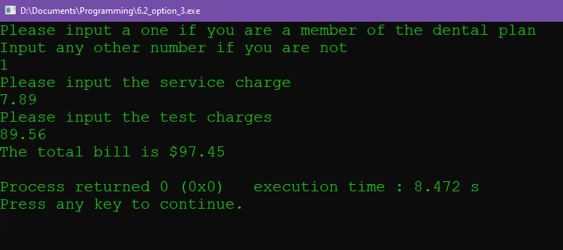

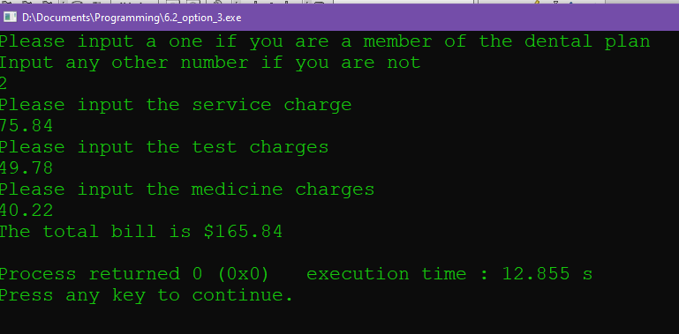

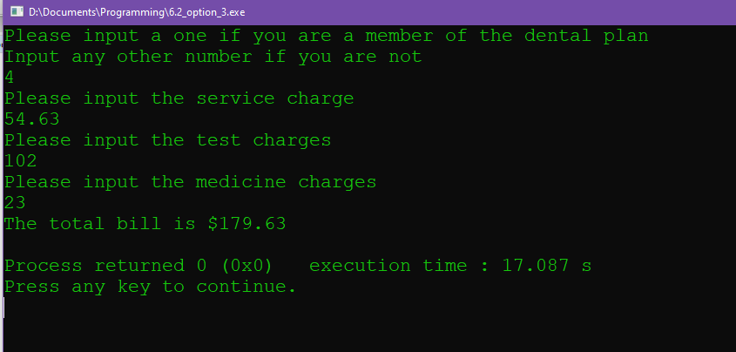

Source Code

#include <iostream>

#include <iomanip>

using namespace std;

float total_bill(float service,float test);

float total_bill(float service,float test,float medicine);

float total_bill(float service,float test)

{

float total=service+test;

return total;

}

float total_bill(float service,float test,float medicine)

{

float total=service+test+medicine;

return total;

}

int main()

{

int plan=0;

float service=0;

float test=0;

float medicine=0;

float total=0;

//init

cout<<"Please input a one if you are a member of the dental plan"<<endl<<"Input any other number if you are not"<<endl;

cin>>plan;

cout<<"Please input the service charge"<<endl;

cin>>service;

cout<<"Please input the test charges"<<endl;

cin>>test;

if (plan==1)

//if a member

{

total=total_bill(service,test);

}

else

{

cout<<"Please input the medicine charges"<<endl;

cin>>medicine;

total= total_bill(service,test,medicine);

}

cout<<"The total bill is $"<<fixed<<setprecision(2)<<total<<endl;

}